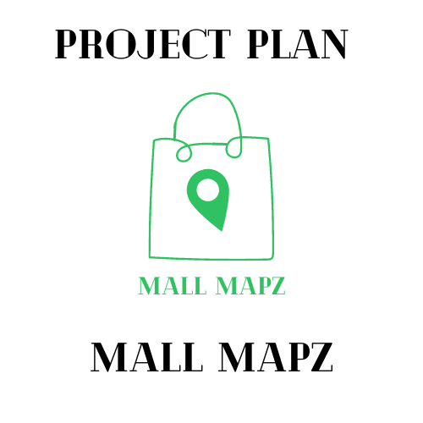





The Cartographers

Lara Leyson, Daniel Pearson, and Romer Rodriguez

February 23, 2022

**Intro:** DP

In this document you can find the objectives of our project and how we are going to achieve them. There is an overview of each topic in this Project Plan that will help us achieve our goal. In the start of this plan, each person a part of the team will do the tasks that they were assigned. The scopes of the plan; containing the problems/solutions, capabilities, business opportunities that can be opened with our newly developed app, and much more that can be found in this document.

Mall Mapz is an interactive user-friendly application made to guide people in the right direction when exploring a new mall that they aren’t so familiar with. An interactive map, store information, ratings, search bar and many more features that are made easy for the user. Efficiency, convenience and satisfaction are what we are pursuing for those shoppings in malls.

**System Scope i:** LL

The goal of this project is to make an app for shoppers all over the country that will help them shop more efficiently. The problem we are trying to solve are shoppers getting lost in malls and wasting valuable time trying to find the exact location of the mall, store, or restaurant they might be looking for. As you may know malls are huge and it is so easy to get lost in, especially if it’s your first time going to a particular mall. Additionally, some shoppers would like to know what stores and restaurants are at the mall before they go. Mall Mapz has a list of all the stores in the particular mall you are going to as well as store descriptions. Moreover, in Mall Mapz you can heart specific stores or restaurants and it will appear in your favorites on your profile page and Mall Mapz will let you know that it is at the mall you are going to. So you will never leave without going to your favorite stores again. The functions mentioned above along with other functions our app offers will help shoppers shop more efficiently.

**System Scope ii:** RR

Here at “The Cartographers” we hope with the release of “Mall Mapz” to make a fully functional application that helps users find where they want to go, what they want to get, and be satisfied with the features the application provides. If these can be checked off, it can lead to the app being more popular leading to increase of profits through app monetization and advertisements placed in. Because in the end, the big goal is to make money from this app. If the user can be satisfied with what is provided and the support given from us, it will lead to them using the app more and sharing it with others, therefore making us more money. Ultimately, we hope to achieve this goal of making money through keeping our users happy and coming back everytime they need to use this app.

Now onto how this app benefits the users of this app. First, the main selling point of this app is its large database of maps of malls from all over the country. Each with an interactive map that helps them find the store they want and how to get there. The app is also integrated with a gps function that helps the user get directions to the mall they selected. To further help the users experience the app includes a reviews system in place in order to see what stores are good and what are some places to avoid. Finally, users will be able to find information about any store in the mall they are located in and be able to save those places as favorites inside their profile.

**System Scope iii:** DP

The 6 major functions of our system that the Cartographers implemented are the GPS, store information, search, reviews, Mapz, and profile. The GPS of our app is made to direct the user to the mall that they so desire. The Store Information function provides the user with information about specific stores that are in the mall. The Search function allows the user to look up any mall, store or restaurant. The Reviews function will allow the user to make a review, look at reviews and it displays the most recent review for any store, mall or restaurant that the user wants to view. Profile function for our app is made for the user to create a profile for themselves showing their most recent mall visits and any favorite spots that they liked. The last major function is the Mapz feature, this function will guide the user into any store or restaurant inside the mall that they so choose.

**System Scope iv:** RR

Please refer to Mall Mapz GitHub Repository for System Context Diagram.

**Schedule:** LL

Please refer to Mall Mapz GitHub Repository for Work Breakdown Structure Chart.

**Staff Organization:** DP

The team leader for the Cartographers is Lara Leyson and the way we are organized is each team member has their own tasks to do, with making sure the work is split up evenly. Trello, Slack and Github are applications we all contribute to help and guide each other when working on this project.

**Tracking and Control Mechanisms**:LL

To keep track of changes in this document The Cartographers are using Slack for quick messaging and communication purposes. We are using Trello to organize meetings, create agendas, keep track of what needs to be done each week and assign tasks to members. To make sure team members are working on the most recent document we are using Google Drive. There is a folder called Software Engineering shared with the team members and in this folder all of those documents are up to date. During the first 15 minutes of class our team has a Stand Up Meeting. The Cartographers also have a 15 minute check in before class depending on if we need to discuss anything further.